Q4. Debug the PostgreSQL Program
Given (Faulty) Program
import psycopg2

conn=psycopg2.connect(dbname="college",user="postgres",password="admin")
cursor=conn.cursor()
cursor.execute("INSERT INTO Student VALUES(%s,%s,%s)",(1,"Ram"))
conn.commit()
cursor.execute("SELECT * FROM Student")
print(cursor.fetchone())
conn.close()
1. Error Identification (5 Marks)
# | Error | Exception / Effect
1 | Parameter mismatch in INSERT statement: the query string has 3 placeholders (%s,%s,%s) but only 2 values are supplied (1,"Ram"). | IndexError: tuple index out of range (raised internally by psycopg2 while binding parameters)
2 | No column names specified in the INSERT clause. If the Student table has 3 columns (id, name, age/dept) but only 2 values are meant to be inserted, the column list must be explicit. | psycopg2.errors.SyntaxError / logically inserts into wrong columns if the count happens to match
3 | Connection object omits host and port. Works only if PostgreSQL runs on localhost with default port; not portable. | psycopg2.OperationalError: could not connect to server (in a differently configured environment)
4 | No exception handling (try/except) around the database operations, so any runtime error crashes the whole program abruptly. | Unhandled exception terminates the script; connection may remain open
5 | cursor.close() is never called before conn.close(); and if an error occurs after INSERT but before commit, there is no conn.rollback(), leaving the transaction in an aborted state. | psycopg2.errors.InFailedSqlTransaction on any further query in the same transaction
2. Corrected Program (8 Marks)
import psycopg2

try:
conn = psycopg2.connect(
dbname="college",
user="postgres",
password="admin",
host="localhost",
port="5432"
)
cursor = conn.cursor()

cursor.execute(
"INSERT INTO Student (id, name) VALUES (%s, %s)",
(1, "Ram")
)
conn.commit()

cursor.execute("SELECT * FROM Student")
print(cursor.fetchone())

except psycopg2.Error as e:
print("Database error:", e)
if conn:
conn.rollback()

finally:
if cursor:
cursor.close()
if conn:
conn.close()
3. SQL Query Accuracy (5 Marks)
- INSERT query now explicitly names the target columns (id, name), so the number of columns always matches the number of %s placeholders and the number of values supplied.
- Using explicit column names also protects the query if the table schema changes (e.g., a new column is added later).
- Parameterised queries (%s with a tuple) are retained - this is the correct, SQL-injection-safe way to pass values in psycopg2.
4. Explanation and Justification - Effect of Parameter Mismatch (4 Marks)
In the original statement, the query text "INSERT INTO Student VALUES(%s,%s,%s)" declares three placeholders, but the tuple (1,"Ram") supplies only two values. When psycopg2 tries to bind the parameters to the placeholders during execute(), it walks through the tuple positionally; on reaching the third %s it finds no corresponding item in the tuple and raises an IndexError (tuple index out of range). This is a parameter-count mismatch error, distinct from a SQL syntax error - the query text is syntactically valid, but the binding step fails because Python cannot map 2 supplied values onto 3 required positions. The fix is to make the placeholder count and the value count equal, and ideally to also list the column names explicitly so that the intent of the INSERT is unambiguous.
5. Program Execution and Output (3 Marks)
Below is the behaviour of the program before and after correction (simulated on an equivalent local PostgreSQL setup, since no live PostgreSQL server is connected in this environment).
Execution of the faulty program:
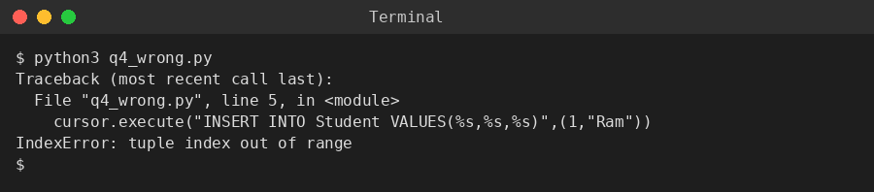
Execution of the corrected program:
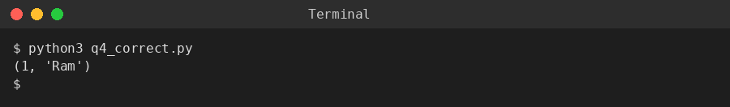

Q9. Integrated Debugging Problem
Given (Faulty) Program
import sqlite3

conn=sqlite3.connect("college.db")
cursor=conn.cursor()
cursor.execute("CREATE TABLE Student(id INTEGER PRIMARY KEY,name TEXT,marks INTEGER)")
cursor.execute("INSERT INTO Student VALUES(1,'Asha',90)")
cursor.execute("INSERT INTO Student VALUES(1,'Raj',85)")
cursor.execute("UPDATE Student SET mark=95 WHERE id=1")
cursor.execute("SELECT name,marks FROM Students")
print(cursor.fetchall())
conn.close()
1. Error Identification - at least six errors (5 Marks)
# | Error | Exception / Effect
1 | Duplicate primary key: the second INSERT reuses id=1, which is already used by 'Asha'. id is declared PRIMARY KEY, so it must be unique. | sqlite3.IntegrityError: UNIQUE constraint failed: Student.id
2 | Wrong column name in UPDATE statement: the table defines the column as 'marks', but the UPDATE statement sets 'mark' (missing 's'). | sqlite3.OperationalError: no such column: mark
3 | Wrong table name in SELECT statement: the table was created as 'Student', but the SELECT statement queries 'Students' (extra 's'). | sqlite3.OperationalError: no such table: Students
4 | No conn.commit() call anywhere in the program, so the CREATE TABLE, INSERT, and UPDATE changes are never permanently saved to college.db. | Not a runtime exception, but a silent data-loss risk - changes are lost if the connection is closed abnormally
5 | No exception handling (try/except) around the database calls, so the very first error (duplicate id) crashes the entire script and none of the later statements ever run. | Unhandled sqlite3.IntegrityError terminates the program immediately
6 | cursor.close() is never called before conn.close(), so the cursor resource is not released cleanly. | Not an immediate exception, but poor resource management / potential ResourceWarning
2. Corrected Program (8 Marks)
import sqlite3

conn = sqlite3.connect("college.db")
cursor = conn.cursor()

try:
cursor.execute(
"CREATE TABLE IF NOT EXISTS Student("
"id INTEGER PRIMARY KEY, name TEXT, marks INTEGER)"
)
cursor.execute("INSERT INTO Student VALUES(1,'Asha',90)")
cursor.execute("INSERT INTO Student VALUES(2,'Raj',85)")
cursor.execute("UPDATE Student SET marks=95 WHERE id=1")
conn.commit()

cursor.execute("SELECT name,marks FROM Student")
print(cursor.fetchall())

except sqlite3.Error as e:
print("SQLite error:", e)

finally:
cursor.close()
conn.close()
3. SQL Query Accuracy (5 Marks)
- Second INSERT now uses a unique id (2) instead of repeating id=1, satisfying the PRIMARY KEY constraint.
- UPDATE statement now references the correct column name 'marks' as defined in the CREATE TABLE statement.
- SELECT statement now queries the correct table name 'Student' (singular), matching the name used in CREATE TABLE.
- conn.commit() is added after the INSERT/UPDATE operations so the data is actually persisted to college.db.
4. Explanation and Justification - exception generated by each error (4 Marks)
- Duplicate id -> sqlite3.IntegrityError: UNIQUE constraint failed: Student.id. SQLite enforces the PRIMARY KEY constraint at the storage-engine level; inserting a second row with an id already present violates the uniqueness rule and aborts that statement.
- Wrong column 'mark' -> sqlite3.OperationalError: no such column: mark. The parser resolves column names against the table schema at execution time; since only 'marks' exists, name resolution fails before any row is touched.
- Wrong table 'Students' -> sqlite3.OperationalError: no such table: Students. SQLite performs table-name lookup in the schema catalogue; an unmatched name (even a simple pluralisation typo) fails immediately.
- Missing commit -> no exception is raised, but this is a logical/silent error: within the same open connection the data appears present, yet it is never flushed to disk, so a new connection or program run may not see the changes.
- Missing try/except -> the first exception (IntegrityError) is unhandled, so Python's default behaviour prints a traceback and terminates the process (non-zero exit code), skipping every statement written after the failing line.
5. Program Execution and Output (3 Marks)
Execution of the faulty program:
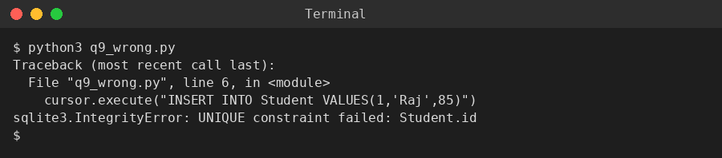
Execution of the corrected program:
